Lab 1-1 Exploring Business Requirements
Goals | Read the ABC Company document to become familiar with the business scenario for the fictitious company used throughout the course.
Time | 5 – 10 minutes
Environment | 
Instructions:
Read the following ABC Company document.

ABC Company

Business Scenario
ABC Company sells food and non-food items to restaurant chain customers. Formerly it sold to its United States (US) customers. Last year ABC Company purchased several companies abroad in Italy, England, France, and Germany. ABC Company wants to ensure a smooth cultural integration. An aspect of this includes extending its vision to its recent acquisitions.

ABC Company’s vision includes the following points:
- Enable current employees to ask their most pertinent business questions themselves;
- Up-to-date sales performance monitoring, especially if it can be exception-driven, will enable the company to better focus its management and customer service efforts; and
- Make data directly available to its customers so they can better analyze their purchase history and compare it to what is being purchased regionally.

You are the consultant that was involved with the first implementation in the prior year. ABC Company has asked you back to assist with integrating its acquisitions into its reporting. The first country to focus on is France.

From quickly skimming your notes on this client, you recognize that:

Source Data – Previous
- ABC Company employees think about their business in terms of sales, products and product hierarchies, time periods, and customer-sales force relationships.
- There are five levels of products depicted as follows:
Total Product
Type
Sub-Type
Generic Product
Specific Product
- There are five levels in the customer-sales organization depicted as follows:
Total Organization
Region
District
Sales Representative
Customer

New Scope
- Build a database to store Siebel Analytics Metadata for impact analysis.
- Build additional tables/star schema and conform dimensions.
- Set up Siebel Analytics to be a global reporting environment; start with France.
Lab 1-2 Setting Up the Development Environment
Goals | To set up a development environment before beginning to implement the ABC Company business requirements.
Scenario | Before beginning development, you must configure your system for development. You will copy and paste the existing repository to the correct folder, create a new, empty Web Catalog to store your requests and dashboards, and modify the appropriate configuration files.
Time | 15 – 20 minutes
Instructions:
- Update the ABC ODBC data source to point to the ASASupplier2 database. This is a copy of ABC Company’s original Supplier2 database that you will modify and use for development purposes.
  - Select Start > Programs > Administrative Tools > Data Sources (ODBC).
  - In the ODBC Data Source Administrator dialog box, click the System DSN tab.
  - Select the ABC data source.
  - Click Configure.
  - Click Next.
  - Click Next.
  - In the Change the default database to: drop-down menu, select ASASupplier2.
  - Click Next.
  - Click Finish.
  - Click Test Data Source.
  - Click OK when the test completes successfully.
  - Click OK.
- Create an ODBC connection for the D1_Returns2 fact table. This table will be used to provide proof-of-concept examples in later labs, and is referenced in your development repository.
  - In the ODBC Data Source Administrator dialog box, click the System DSN tab.
  - In the ODBC Data Source Administrator dialog box, click Add.
  - In the Create New Data Source dialog box, select Driver do Microsoft Excel(*.xls) and click Finish.
  - In the ODBC Microsoft Excel Setup dialog box, enter the following:
Data Source Name | D1_Returns2
Description | <Leave Blank>
Version | Excel 97-2000
  - Click Select Workbook.
  - In the Select Workbook dialog box, verify that Excel Files (*.xls) is selected from the List Files of Type drop-down list and navigate to C:\Data\ANADV in the right pane.
  - Select D1_Returns2.xls in the left pane and click OK.
  - Click OK.
  - Click OK to close the ODBC Data Source Administrator dialog box.
- Stop the Siebel Analytics services before making changes to your development environment.
  - Select Start > Programs > Administrative Tools > Services.
  - Stop the Siebel Analytics Web service.
    - Right-click Siebel Analytics Web.
    - Select Stop.
    - Wait for the service to stop completely before proceeding to the next step.
  - Stop the Siebel Analytics Server service.
  - Verify that the Siebel Analytics Scheduler service is stopped.
  - Minimize the Services dialog box.
- Copy and paste the ServArchAdv.rpd repository to the appropriate Siebel Analytics repository folder. This is the repository from ABC Company’s first implementation.
  - Navigate to C:\Data\ANADV.
  - Copy ServArchAdv.rpd.
  - Paste it into C:\SiebelAnalytics\Repository.
- Modify NQSConfig.ini so that the Siebel Analytics Server loads the ServArchAdv.rpd repository.
  - Navigate to C:\SiebelAnalytics\Config.
  - Double-click NQSConfig.ini to open it using Notepad.
Note: You may need to adjust the font to a smaller size when this file is first opened.
  - Locate the [ REPOSITORY ] section.
  - Modify the file to load the ServArchAdv.rpd repository. Your results should look similar to the following:
[ REPOSITORY ]
Star = ServArchAdv.rpd, DEFAULT;
#Star = demo1.rpd, DEFAULT;
#Star = siebelanalytics.rpd, DEFAULT;
  - Save and close NQSConfig.ini.
- Create a new Web Catalog folder to store a new, empty Web Catalog. This provides a clean development environment for you to work with.
  - Navigate to C:\SiebelAnalyticsData\Web.
  - Rename the Catalog folder Catalog_Backup.
  - Create a new folder named Catalog in the same directory. When you start and stop the Siebel Analytics Web service in a later step, a new Web Catalog called default.webcat will be created in this Catalog folder.
- Verify that the file instanceconfig.xml has the correct Web Catalog path.
  - Navigate to C:\SiebelAnalyticsData\Web\config.
  - Make a backup copy of instanceconfig.xml.
Note: Best practice is to always make a backup copy of the file instanceconfig.xml before making any changes.
  - Right-click instanceconfig.xml and open it with Notepad.
  - Change the catalog path to C:/SiebelAnalyticsData/web/catalog/default.webcat. Your file should look similar to the following:
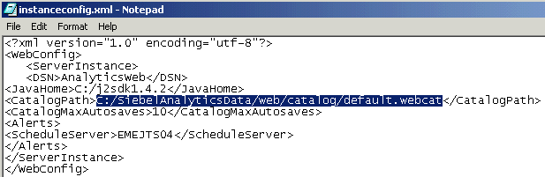
  - Save and close instanceconfig.xml.
- Restart the Siebel Analytics services to apply your changes.
  - Restart the Siebel Analytics Server and Siebel Analytics Web services.
  - Navigate to C:\SiebelAnalyticsData\Web\Catalog.
  - Verify that a default.webcat.version file and a default.webcat.10.autosave file were created in the Catalog folder. By default, Siebel Analytics Web performs a Web Catalog backup every five minutes. The version file contains information about the last known good Web Catalog backup.
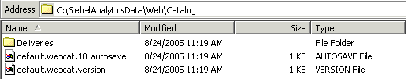
  - Stop the Siebel Analytics Web service. This creates a new Web Catalog in the Catalog folder.
  - Navigate to C:\SiebelAnalyticsData\Web\Catalog.
  - Verify that a new Web Catalog called default.webcat was created in the Catalog folder.
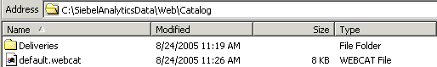
  - Start the Siebel Analytics Web service.
Lab 1-3 Building and Querying a Dependency Tracking Data Source
Goals | To build a dependency tracking data source and report off of it in Siebel Answers.
Scenario | The project team is looking to either modify or remove Region from the data source. Prior to doing this, the transactional database, data warehouse, and Analytics reporting teams would like to understand the impact of the proposed change.
Time | 15 – 20 minutes
Instructions:
- Start Siebel Analytics Administration and open ServArchAdv.rpd in online mode.
  - Select Start > Programs > Siebel Analytics > Siebel Analytics Administration.
  - Select File > Open > Online.
  - Verify that the user name is Administrator and the password is blank.
  - Click Open.
- Export the metadata to a comma-separated value (CSV) file which will then be imported for querying. You will export the file, add a primary key column and populate it with unique values, and then re-save the file as an Excel spreadsheet.
  - In the Siebel Analytics Administration Tool, select Tools > Utilities.
  - In the Utilities dialog box, select Dependency Tracking and click Execute.
  - In the Save As dialog box, browse to the C: directory and enter DT.csv to save the file as C:\DT.csv.
  - Click Save.
  - Using Windows Explorer, double-click C:\DT.csv to open it using Microsoft Excel.
  - In Microsoft Excel, select File > Save As.
  - In the Save As dialog box, specify file type Microsoft Excel 97-2002 & 5.0/95 Workbook (*.xls) and name the file DT.xls.
  - Click Save.
  - Add a primary key column to the spreadsheet and generate unique values for each row.
    - Enter Primary Key in row 1 for the column to the right of Physical Column (M1).
    - In cell M2, type the number 1.
    - In cell M3, type the number 2.
    - In cell M4, type the number 3.
    - For the M column only, highlight rows 2 through the last record.
    - Select Edit > Fill > Series.
    - In the Series dialog box, click OK.
  - Select File > Save and close Microsoft Excel.
- Create an ODBC connection to the Microsoft Excel file you’ve created.
  - Select Start > Programs > Administrative Tools > Data Sources (ODBC).
  - In the ODBC Data Source Administrator dialog box, click the System DSN tab.
  - Click Add.
  - In the Create New Data Source dialog box, select the Driver do Microsoft Excel (*.xls) driver and click Finish.
  - In the ODBC Microsoft Excel Setup dialog box, enter the following:
Data Source Name | DT
Description | Excel DT
Version | Excel 97-2000
  - Click Select Workbook.
  - In the Select Workbook dialog box, select Excel Files (*.xls) from the List Files of Type drop-down menu and navigate to the C:\ drive in the right pane.
  - Select DT.xls in the left pane and click OK.
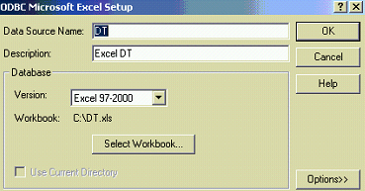
  - Click OK.
  - Click OK.
- Import the dependency tracking spreadsheet as a data source in the Physical layer of your repository and set the primary key column.
  - In the Siebel Analytics Administration Tool, select File > Import > From Database.
  - In the Select ODBC Data Source dialog box, select the following:
Connection Type | ODBC 3.5
DSN | DT
User Name | None
Password | None
Siebel Tables | Not checked
  - Click OK.
  - In the Import dialog box, check all check boxes.
  - Click Import.
  - Click Close.
  - Expand the DT data source and C:\DT folder in the Physical layer to expose the DT$ table.
  - Double-click the DT$ table in the Physical layer.
  - In the Physical Table dialog box, click the Keys tab and click New.
  - In the Physical Key dialog box, select the check box for Primary Key and click OK.
  - Click OK to close the Physical Table dialog box.
- Map the dependency tracking table to the Business Model and Mapping layer.
  - Right-click in the Business Model and Mapping layer and select New Business Model.
  - In the Business Model dialog box, enter Analytics Metadata as the name. Do not mark the model as available for queries.
  - Click OK.
  - Drag and drop the DT$ table from the Physical layer onto the Analytics Metadata Business Model.
  - Right-click the DT$ logical table and select Duplicate.
  - Rename the original DT table Dimension.
    - Right-click the DT$ logical table and select Rename.
    - Enter Dimension as the name.
    - Click on another table or in the white space to save the new name.
  - Rename the duplicate DT table Fact.
  - Use CTRL-click to select both the Dimension and Fact logical tables.
  - Right-click the Dimension logical table and select Business Model Diagram > Selected Tables Only.
  - Click the New Complex Join button .
  - In the Logical Table Diagram window, click Dimension and then click Fact.
  - Click OK in the Logical Join dialog box to confirm the join.
  - Close the Logical Table Diagram window.
- Map the dependency tracking table to the Presentation layer.
  - Right-click in the Presentation layer and select New Presentation Catalog.
  - Enter Analytics Metadata Reporting as the name and click OK.
  - Drag and drop the Dimension logical table onto the Analytics Metadata Reporting Presentation layer catalog. Your screen should look as follows:
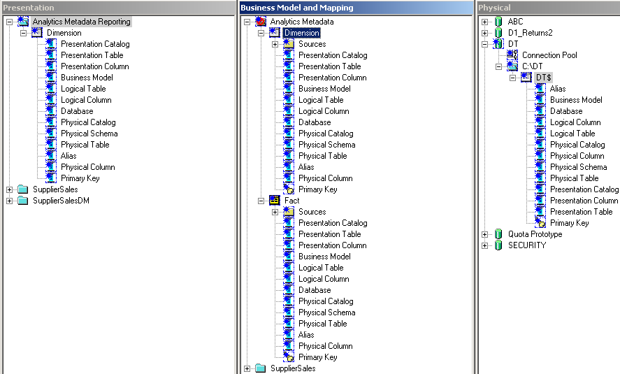
- Check in and save your changes.
  - Select File > Check In Changes to check in your changes for the repository file.
  - Click Yes to check consistency.
  - Click Yes to make the model available for queries.
  - Click OK.
  - Select File > Save.
- Query the DT data source through Analytics to understand whether or not there is an impact if the Region column were to be modified.
  - Start Siebel Analytics Web and log in as Administrator.
    - Select Start > Programs > Siebel Analytics > Siebel Analytics Web.
    - Enter Administrator as the User ID.
    - Leave the password blank.
    - Click Log In.
  - Click the Answers link.
  - Click the Analytics Metadata Reporting subject area.
  - In the request, select all the columns in the Dimension table.
  - Filter on Physical Column equal to Region.
    - Click the Filter icon on the Physical Column.
    - In the Create/Edit Filter dialog box, enter Region in the Value field.
    - Click OK.
  - Click the Results tab.
- How many records are returned?
- Which databases reference Region?
- Is Region included in any Aliases? Why might this question be asked?
- Log out of Siebel Answers.
- Leave the Siebel Analytics Administration Tool open for the next lab.
Solutions 1-3 Building and Querying a Dependency Tracking Data Source
Answers
9. How many records are returned?
13
10. Which databases reference Region?
ABC and Quota Prototype
11. Is Region included in any Aliases? Why might this question be asked?
No. If any additional aliases or other aspects were created in the physical layer, it is likely that there would be more dependencies on Region in the Business Model/Mapping and Presentation layers.
Lab 1-4 Performing Quick Dependency Analysis
Goals | To use the Display Related functionality in the Siebel Analytics Administration Tool to identify any risks to modifying an object.
Scenario | The project team is looking to either modify or remove Region from the data source. Prior to doing this, the transactional database, data warehouse, and Analytics reporting teams would like to understand the impact of the proposed change.
Time | 5 – 10 minutes
Instructions:
- If necessary, open the ServArchAdv.rpd in online mode and log in as Administrator with no password.
- Identify the dependencies on Region.
  - Expand the SupplierSales presentation layer subject area.
  - Expand the Customers dimension table.
  - Right-click Region in the Customers dimension table.
  - Select Display Related > All Types.
  - Click Yes to confirm the query.
  - How many dependencies does Region have?
- Identify the number of elements for the Region logical level object.
  - Locate the Region logical level object from the Dependencies list. It may be identified by the green logical level icon or by scrolling to the right to see the Type column in the Query Repository dialog bog.
  - Double-click the Region logical level. What happens? Click Yes to check out the objects.
  - How many elements are at this level?
  - Click Cancel.
- Identify the object type.
  - In the Query Repository dialog box, select the CustPartOne object.
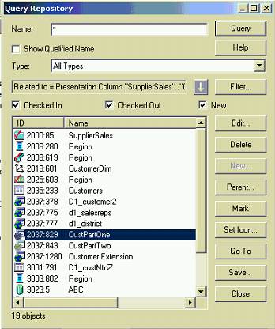
  - What type of object is it?
- What do you tell the OLTP, Data Warehouse and Analytics teams as to whether or not there would be an impact if the column Region were to be modified?
- Close all windows and do not check in any changes. This ensures that if you made any accidental changes while examining the repository, they will be discarded before the next lab.
Solutions 1-4 Performing Quick Dependency Analysis
Answers
2.f. How many dependencies does Region have?
19.
3.b. Double-click the Region logical level. What happens?
The user is prompted to check out the object. Then the object is opened for editing.
3.c. How many elements are at this level?
3.
4.b Select the object in the following screenshot. What type of object is it?
Logical Table Source.
5. What do you tell the OLTP, Data Warehouse and Analytics teams as to whether or not there would be an impact if the column Region were to be modified?
There would be an impact if Region were removed from the data source. There are 19 areas in the Analytics Metadata which would be impacted. It is also necessary to convey the impact in the number of reports and dashboards (if possible) that would need to be altered, re-validated, and regression tested.

